9.53: 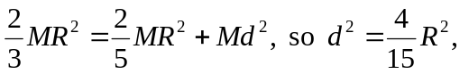and the axis comes nearest to the center of the sphere at a distance 